

**Dear Reader,**

**Thank you for your interest in sharing results from the Community College Health Study (CCHS) with your network. This NIH-funded study aims to better understand how to provide resources and programming to enhance the sexual and relationship health of community college students and prevent sexual assault.**

**The most recent edition of the CCHS newsletter shared findings about how sexual health education may affect the way students think about safe sex behaviors and healthy relationships. On the next page is a short blurb for you to use when you are sharing information about these study findings with other members of your college, organization, or network. You can copy and paste the information on the next page into a listserv or body of an email.**

**If you choose to share this information via email, our suggested subject line for this blurb is “How Sex Ed May Affect Students’ Beliefs and Attitudes About Safe Sex.” If you have been working with our Community College Health Study team to involve your students or staff in this study, feel free to include a statement at the beginning of the blurb such as “We have been working with researchers at iRT to better understand our students’ health and the sexual and relationship health resources they need to thrive!”**

**If you have any questions, please feel free to email our study coordinator at** [**CCHstudy@irtinc.us**](mailto:CCHstudy@irtinc.us)**.**

**Thank you,**

**The Community College Health Study team**



**As a part of the Community College Health Study, community college students were randomly assigned to take a sexual health education course, *Media Aware*, either immediately or at a later date. *Media Aware* is an online sexual health program that includes media literacy education.**

**After taking (or not taking) *Media Aware*, students filled out questionnaires that assessed their attitudes towards risky sexual behaviors, their confidence in practicing safe sex behaviors (self-efficacy), and ideas about how their peers experience sex and relationships (normative beliefs). Immediately following the completion of their assigned sexual health program, students who took *Media Aware* reported more positive attitudes towards safe sex behaviors, greater confidence in their ability to practice safe sex behaviors, and healthier normative beliefs about their peers compared to students who did not take the course.**

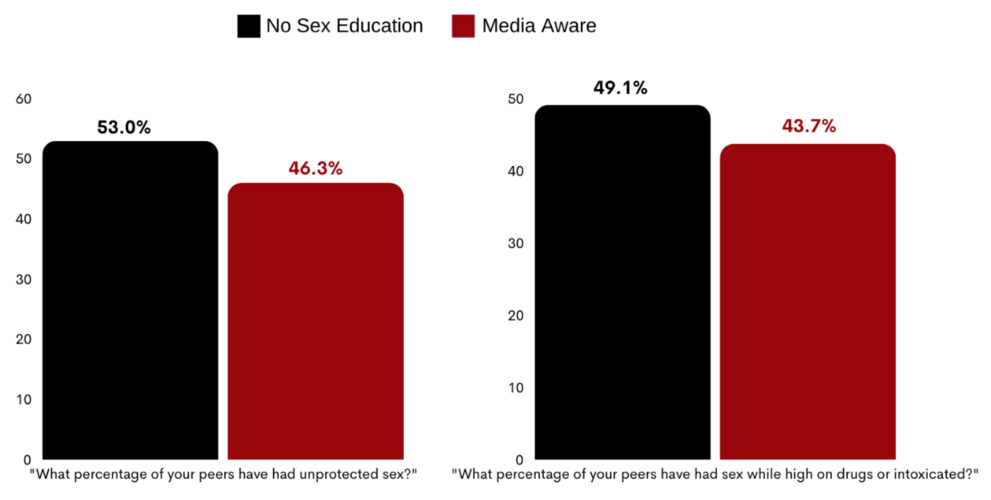

**These are important findings because The Theory of Planned Behavior1 suggests that young adults’ attitudes and self-efficacy about safe sex and relationship behaviors can influence their future health decisions. In addition, according to Social Norms Theory2, young adults’ views of their peers’ behaviors (normative beliefs) also influence their behavior as they may imitate their peers to fit in. As such, promoting healthier attitudes, self-efficacy, and normative beliefs may improve the likelihood that young adults will make healthy decisions in their future sexual or romantic relationships.**

**Interested in reading the full newsletter and/or receiving updates on study findings? Go to** [**https://cchealthstudy.com/results/**](https://cchealthstudy.com/results/) **and fill out the form at the bottom of the webpage to subscribe to the newsletter.**

1. Ajzen I. The Theory of Planned Behavior. Organizational Behavior and Human Decision Processes. 1991;50(2):179–211.
2. Cialdini RB, Trost MR. Social influence: Social norms, conformity and compliance. In: Gilbert DT, Fiske ST, Gardner L, eds. The Handbook of Social Psychology. 4th ed. New York, NY: McGraw-Hill; 1998:151–19